**Swinburne University of Technology**

COS60007

Creating Web Application and Databases Assignment 3

Analytical Report on Web Accessibility

Submitted by:

Bikesh Nath Khanal (101985810)

Contents

Executive Summary 1

Introduction 1

Website introduction 1

Objective of the report 1

Outline of the reports structure 2

Accessibility Analysis 2

Method of analysis 2

Conclusion 4

References 5

# 

# Executive Summary

In this present world internet is the main source of information to the people from students to researcher. The thing that is required are internet connectivity and a device to show the information. Everyone has got the right to get the information presented in the internet. Web pages that displays the information should be user friendly and can be perceived by anyone with any kind of physical and mental state. This is web accessibility. There are some guidelines and rules developed by Worldwide Web Consortium (W3C) that specifies the web accessibility.

As specified by W3C web accessibility are based on four principles:

* Perceivable: achievable by vision or hearing using browser or any other technology such as screen readers.
* operable: should be controllable to users either by mouse, keyboard or any other device
* Understandable: vivid content
* Robust: accessible contents to new or old technologies (Worldwide Web Consortium (W3C), web content accessibility guidelines (WCAG) 2.1).

For example, the blind people can also access the internet information using some software’s such as Screen reader. But if the headings, sections and article are not properly specified in text on the webpages the blind people are deprived from the information. Not only blind people, deaf people and physically and mentally disabled individuals have equal right to acquire the information in the websites.

# Introduction

## Website introduction

The website which I have created as my assignment 2 contains the enough information that anyone can use while traveling to my home town Mustang, which is western part of country Nepal. There are enough hyperlinks on the web pages to navigate from one page to another or through the page. Organized menu with home, hometown, quiz, Manage and contact are the part of the Menus. On hometown page, there is detailed information about my hometown. There is a quiz section where reader is asked some question about their details and some question they learned using my web page. They are given three attempts to complete the quiz and get maximum answers correct. All their score, attempts and personal information are kept securely on remote Swinburne university database on table named as Attempts. The Manage webpage is used to display the information on the database for the supervisors to see, delete and update the marks for the attempts made by the users.

## Objective of the report

The objective of this report is to develop short description in web accessibility on the webpage I developed for assignment 2 as course requirement.

## Outline of the reports structure

All the four principles of WCAG mentioned above are taken in mind to analyze my webpage. There are some tools to check the web accessibility and thus they are used to validate my webpage. I have included the details report of the data and information collected using these tools.

# Accessibility Analysis

## Method of analysis

As mentioned and given there are many extensions that can be used for accessibility evaluations. I have used the extension on Firefox web browser i.e. WCAG (web content Accessibility Guidelines) contrast checker and color contrast analyzer. The below image shows the report and errors of the webpage hometown.

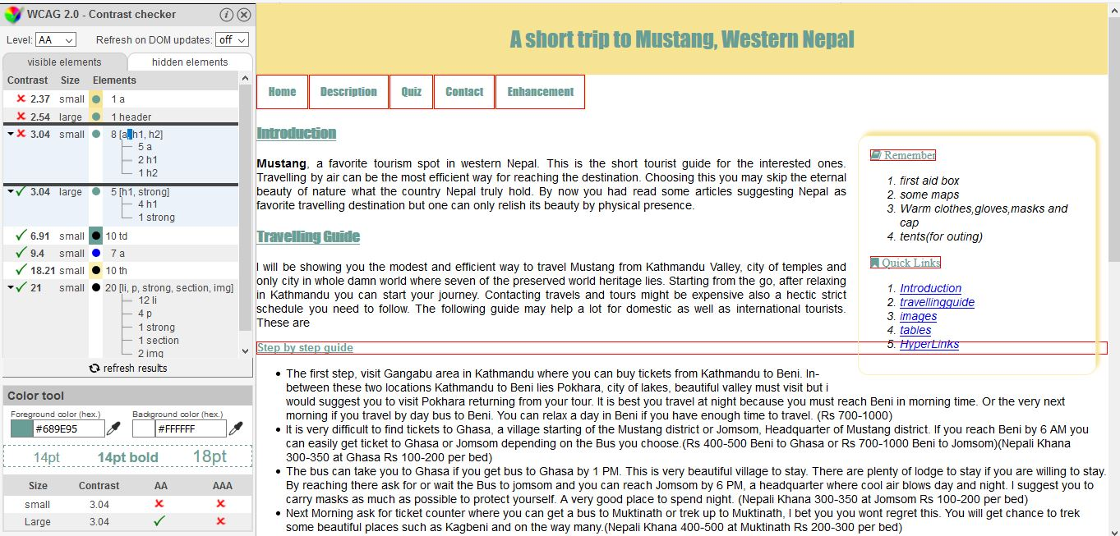

Figure 1: Using Contrast checker

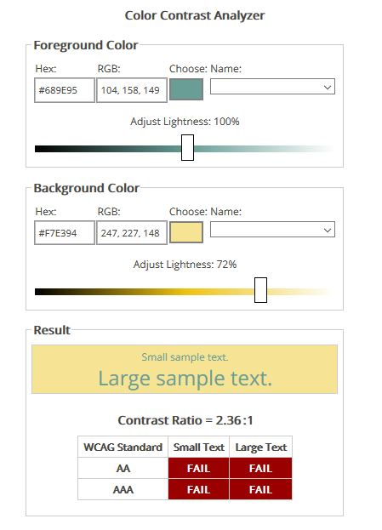

Figure 2: Color contrast Analyzer

There were major issues in the websites I developed. The contrast level of my header and footer part is insufficient. Similarly, there are major issues with contrast with the menus as foreground and background color doesn't meet the contrast level as expected. But the part in the websites such as articles, aside, headings of different sections, tables, hyperlinks do satisfy the contrast level as expected by WCAG.

|  |  |  |  |
| --- | --- | --- | --- |
| Elements | Foreground color | Background Color | Contrast level |
| Header, footer | #689E95 | #F7E394 | 2.37 (insufficient) |
| Menus (a) and aside (h1, h2) | #689E95 | #FFFFFF | 3.04 (insufficient) |
| Sections (12 li, 4p) | #000000 | #FFFFFF | 21 (sufficient) |

Table 1: Data acquired from WCAG contrast checker

While analyzing the contrast level of the header, text color used is #689e95 and the background color is #f7e394, font size is 22.5 Pt and font-weight: normal. So, the element has the insufficient color contrast as 2.37:1 as specified by above image using color contrast analyzer. Similarly, the footer contains the same color combinations so as raise a same issue. The expected contrast level for header and footer must be 3:1 for the given font size and color.

Similarly, the menus element a and h1 and h2 aside sections heading have the contrast level of 3.04:1 which is insufficient color contrast level with foreground #689E95 and background #FFFFFF. Other elements like h1 from sections, li in list section, p in different section have the perfect contrast level of 21 without errors.

There are people with low vision who can experience low contrast like there is not many dark or bright areas and every text and element in that section tend to be of same brightness for them and it will be very difficult for them to distinguish between borders and details (Axe, Text elements must have enough color contrast against the background). Also, for normal as well as people with difficulties text with close in contrast with background color will be difficult to read. Thus, all the text elements should have enough color contrast between foreground and background color.

# Conclusion

Therefore, the people suffering from different types of disability such as vision, hearing, movement can properly access the information in the webpages if and only if the contents meet the WCAG guidelines. While designing the web pages with web accessibility in mind should help in distributing the information for broader population.

Some of the implementation for achieving these guidelines are:

* Appropriate alternative text for images
* Proper headings for each paragraphs or sections
* Header in tables
* Proper labeling in forms
* Hyperlinks are properly implemented like avoiding phrases like click more etc.
* Use handlers to avoid excessive use of mouse. (web accessibility on mind (Web AIM), Introduction to Web Accessibility)

As far as my websites is concerned the things there are plenty for room of improvements such as

* color combinations for footer back and foreground color in header and footer should be contrast for example #000000 and #FFFFFFF
* the alternative text for the images must be able to give some information about images
* the phrases like click here and my blog in the hyperlinks section must be replace with other phrases such as Blog of Bikesh Khanal etc.
* the sections for list must have proper headings.

# References

* Axe, Text elements must have enough color contrast against the background received from <<https://dequeuniversity.com/rules/axe/3.1/color-contrast?application=AxeChrome>>
* Web accessibility on mind (Web AIM), Introduction to Web Accessibility retrieved from <<https://webaim.org/intro/#people>>
* Worldwide Web Consortium (W3C), web content accessibility guidelines (WCAG) 2.1 taken from < <https://www.w3.org/TR/WCAG/#low-or-no-background-audio>>